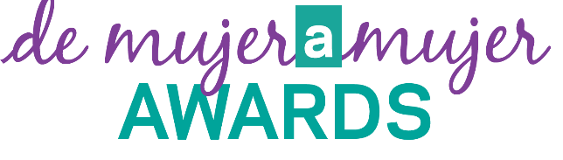
5th Annual

NOMINATION INSTRUCTIONS

As a celebration of the diversity of amazing women in Berks and Greater Reading, Women2Women will be hosting the 5th Annual De Mujer a Mujer Awards Ceremony on June 8, 2023. Three women will be awarded recognition in various categories.

Community Impact Award

- This recipient is a woman who has shown leadership and commitment to the community in Reading and Berks County.

Young Changemaker Award

- This recipient is a young woman between the ages of 18-25 who has shown leadership, dedication and commitment to the community. This young woman shows great potential to be, or is, one of the next women leaders of Berks County.

Small Business Owner Award

This recipient is the owner of a business who is thriving and engaging in the community. The business can be headquartered anywhere in the Greater Reading/Berks County region.

THE PROCESS

A Selection Committee, made up of a diverse group of community leaders, will review all nominations. The recipients will be announced at De Mujer a Mujer Awards Ceremony on Thursday, June 8, 2023.
- You are encouraged to work closely with your nominee to complete their nomination.

Nominations for any award must be submitted using this nomination form and format.
- You may include supporting documents (articles, testimonials, etc) with your completed nomination form.
- All nominees must identify their ethnicity to be of American Indian or Alaska Native, Asian, Black or African American, Native Hawaiian or Other Pacific Islander, and/or Hispanic or Latino.
  - We will accept all nominations but note that we are celebrating the diversity of our community through this award ceremony.

Deadline for submission: Friday, May 5, 2023.

EMAIL COMPLETED FORM OR QUESTIONS TO:
Rachael Romig at rromig@greaterreading.org or 610-898-7775

De Mujer a Mujer Award Nomination Form (page 1 of 2)

Date ______________________

Nominating for (please choose one):
- Community Impact Award
- Young Changemaker Award
- Small Business Owner Award

NOMINEE (For the Award)

Name ____________________________________________________________________________________

Phone ___________________________Email_____________________________________________

Company/Organization________________________________________________________________

Title/Position _______________________________________________________________________

Business Address ____________________________________________________________________

City___________________________State/Province____________Zip/Postal Code _______________

Years in Position____________________

NOMINATOR (Person Nominating)

Name _____________________________________________________________________________

Company/Organization _______________________________________________________________

Title/Position_______________________________________________________________________

Phone__________________________Email_______________________________________________

Latina Initiatives Award Nomination Form (page 2 of 2)

Why are you nominating this woman?

Has this person received previous awards? Y/N (please circle)
If yes, please list name of award, awarding organization, and year received.

What has this nominee accomplished in the last 2 years that has made a positive impact in the community?

